SONG JOURNEY
"the cure"
Olivia Rodrigo
Thread song — it appears in all 5 modules
One song, five layers. Each module adds a new skill to this song. Layer 6 is a bonus.
Form Verse → Chorus → Verse → Chorus → Outro
Verse chords Am · C · F · C
Chorus chords Dm · F · C · G/B
Rhythm One chord per bar. 4 beats each. No capo.
Tempo Practice at 60 BPM. The record feels like 72 BPM.
LAYER 1 Listen Module 1
Listen to the song 3 times.
1. Listen for the guitar. It is acoustic and clean.
2. Listen for the chords changing.
3. Listen for how the song gets louder at the end.
Do it: Count the chord changes in one verse. How many different chords do you hear? ______
You've got it when: You can hum the main hook from memory.
Level up
Listen one more time. Find the moment the chorus starts.
What changes? ______________________________
LAYER 2 Single Notes Module 2
Play the root notes of the verse: A · C · F · C. All of them are on the low E string.
Verse root line · low E string · 4 beats per note
A C A C
e |----------------|----------------|----------------|----------------|
B |----------------|----------------|----------------|----------------|
G |----------------|----------------|----------------|----------------|
D |----------------|----------------|----------------|----------------|
A |----------------|----------------|----------------|----------------|
E |--5--5--5--5----|--8--8--8--8----|--5--5--5--5----|--8--8--8--8----|

F C F C
e |----------------|----------------|----------------|----------------|
B |----------------|----------------|----------------|----------------|
G |----------------|----------------|----------------|----------------|
D |----------------|----------------|----------------|----------------|
A |----------------|----------------|----------------|----------------|
E |--1--1--1--1----|--8--8--8--8----|--1--1--1--1----|--8--8--8--8----|

Play it: 4 beats per note at 60 BPM. Pick each note once per beat.
A = pinky, fret 5 · C = slide up, index on fret 8 · F = index, fret 1
Say each note name out loud.
You've got it when: 2 clean laps at 60 BPM. Your hand moves from fret 8 back to fret 1 without looking.
Level up
Play the same notes on the A string. F stays on the low E.
Level up · A and C on the A string · 4 beats per note
A C F C
e |----------------|----------------|----------------|----------------|
B |----------------|----------------|----------------|----------------|
G |----------------|----------------|----------------|----------------|
D |----------------|----------------|----------------|----------------|
A |--0--0--0--0----|--3--3--3--3----|----------------|--3--3--3--3----|
E |----------------|----------------|--1--1--1--1----|----------------|

LAYER 3 Power Chords Module 3
Optional harder challenge. No score.
Play the whole song with one power chord shape. Play it quietly.
Verse: A5 · C5 · F5 · C5 Chorus: D5 · F5 · C5 · G5
Power chords · root on the low E · 4 beats per chord
A5 C5 F5 C5
e |----------------|----------------|----------------|----------------|
B |----------------|----------------|----------------|----------------|
G |----------------|----------------|----------------|----------------|
D |----------------|----------------|----------------|----------------|
A |--7--7--7--7----|-10 10 10 10----|--3--3--3--3----|-10 10 10 10----|
E |--5--5--5--5----|--8--8--8--8----|--1--1--1--1----|--8--8--8--8----|

D5 F5 C5 G5
e |----------------|----------------|----------------|----------------|
B |----------------|----------------|----------------|----------------|
G |----------------|----------------|----------------|----------------|
D |----------------|----------------|----------------|----------------|
A |-12 12 12 12----|--3--3--3--3----|-10 10 10 10----|--5--5--5--5----|
E |-10 10 10 10----|--1--1--1--1----|--8--8--8--8----|--3--3--3--3----|

Play it: 4 beats per chord at 60 BPM. One soft down-strum per beat.
Move both fingers together when you change chords.
You've got it when: 2 laps, clean and soft. Every change lands on beat 1.
Level up
Play the bassline as single notes. The last note is B, fret 7 — the bass note the record plays under G/B.
Then play one lap loud and one lap very soft.
Level up · bassline as single notes · 4 beats per note
A C F C
e |----------------|----------------|----------------|----------------|
B |----------------|----------------|----------------|----------------|
G |----------------|----------------|----------------|----------------|
D |----------------|----------------|----------------|----------------|
A |----------------|----------------|----------------|----------------|
E |--5--5--5--5----|--8--8--8--8----|--1--1--1--1----|--8--8--8--8----|

D F C B
e |----------------|----------------|----------------|----------------|
B |----------------|----------------|----------------|----------------|
G |----------------|----------------|----------------|----------------|
D |----------------|----------------|----------------|----------------|
A |----------------|----------------|----------------|----------------|
E |-10 10 10 10----|--1--1--1--1----|--8--8--8--8----|--7--7--7--7----|

LAYER 4 Pentatonic Solo Module 4
Solo with A minor pentatonic. Play softly. Leave space between notes.
Four rungs. Climb them in order.
Rung 1 · Rule of 3
Your three starting notes · A minor pentatonic, Pattern 1
A C D
e |----------------------------------|
B |----------------------------------|
G |----------------------------------|
D |----------------------------------|
A |--------------------5-------------|
E |--5-------8-----------------------|

Play it: Put on the song. Improvise 8 bars with these 3 notes.
Start or end every phrase on A. A is the home note.
You've got it when: Your quietest note is as clean as your loudest.
Rung 2 · The whole box
The whole box · A minor pentatonic Pattern 1 · 5th fret
e |--5----------8--------------------|
B |--5----------8--------------------|
G |--5-------7-----------------------|
D |--5-------7-----------------------|
A |--5-------7-----------------------|
E |--5----------8--------------------|

Play it: Play the box up and down, softly. Then improvise anywhere inside it.
Rung 3 · Hammer-ons and slides
h = hammer-on. Pick the first note, then tap the higher fret with your ring finger.
/ = slide. Pick once, keep pressing, slide up.
Hammer-ons and slides · all inside Pattern 1
G A C D G A A
e |--------------------|--------------------|
B |--------------------|--------------------|
G |------------5h7-----|--------------------|
D |--5h7---------------|--5/7-------7-------|
A |--------------------|--------------------|
E |--------------------|--------------------|

Play it: Practice each move slowly. The second note must sound clearly.
Then add them to your 3-note phrases.
Rung 4 · Two soft licks
Lick 1 · going up · ends on A, let it ring
E G A
e |--------------------|
B |--------------------|
G |--------------------|
D |-------5----7-------|
A |--7-----------------|
E |--------------------|

Lick 2 · going down · ends on A, let it ring
D C A
e |--------------------|
B |--------------------|
G |--7----5------------|
D |------------7-------|
A |--------------------|
E |--------------------|

Play it: Learn each lick exactly. Then change one note or change the rhythm.
You've got it when: Your solo uses the box, one hammer-on or slide, and one lick.
Level up
Call and response. Play 2 bars that end away from A. Then play 2 bars that end on A.
Here is one to start with. Then make your own.
Level up · call and response · 4 bars
G A C D D C A G A A
e |----------------|----------------|----------------|----------------|
B |----------------|----------------|----------------|----------------|
G |--------5--7----|--7-------------|--5-------------|----------------|
D |--5--7----------|----------------|-----7--5--7----|--7-------------|
A |----------------|----------------|----------------|----------------|
E |----------------|----------------|----------------|----------------|

LAYER 5 Open Chords Module 5
Play the whole song with open chords. One chord per bar. No capo.
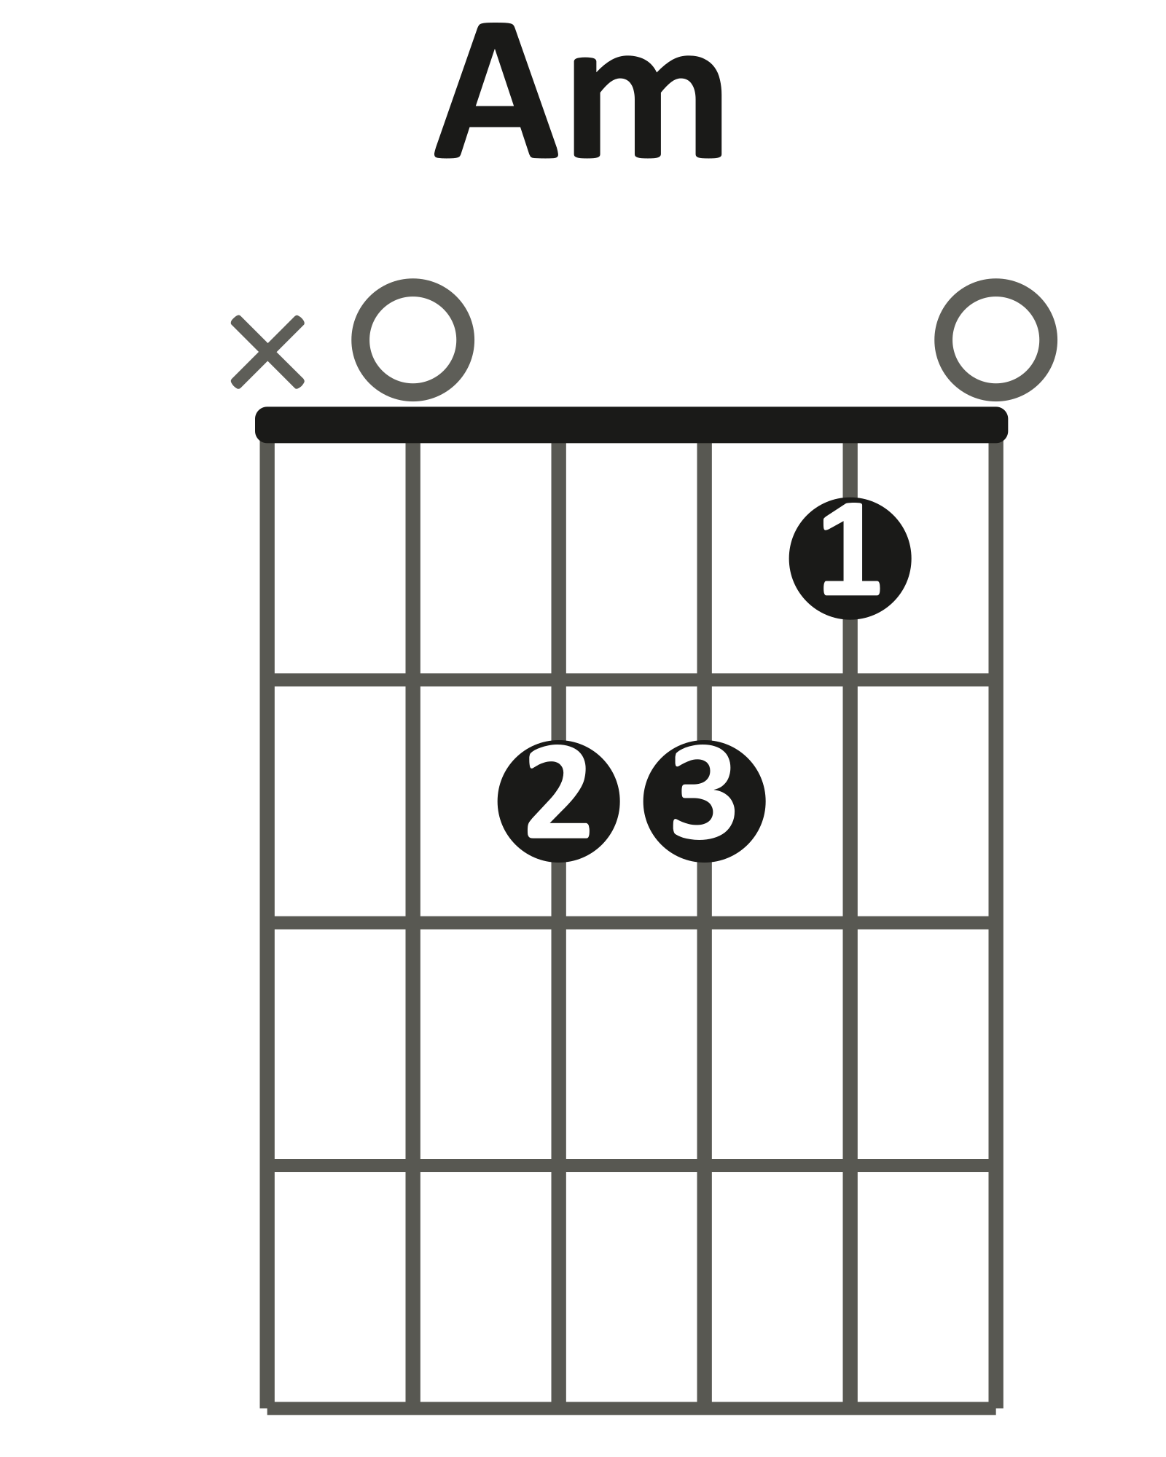 | 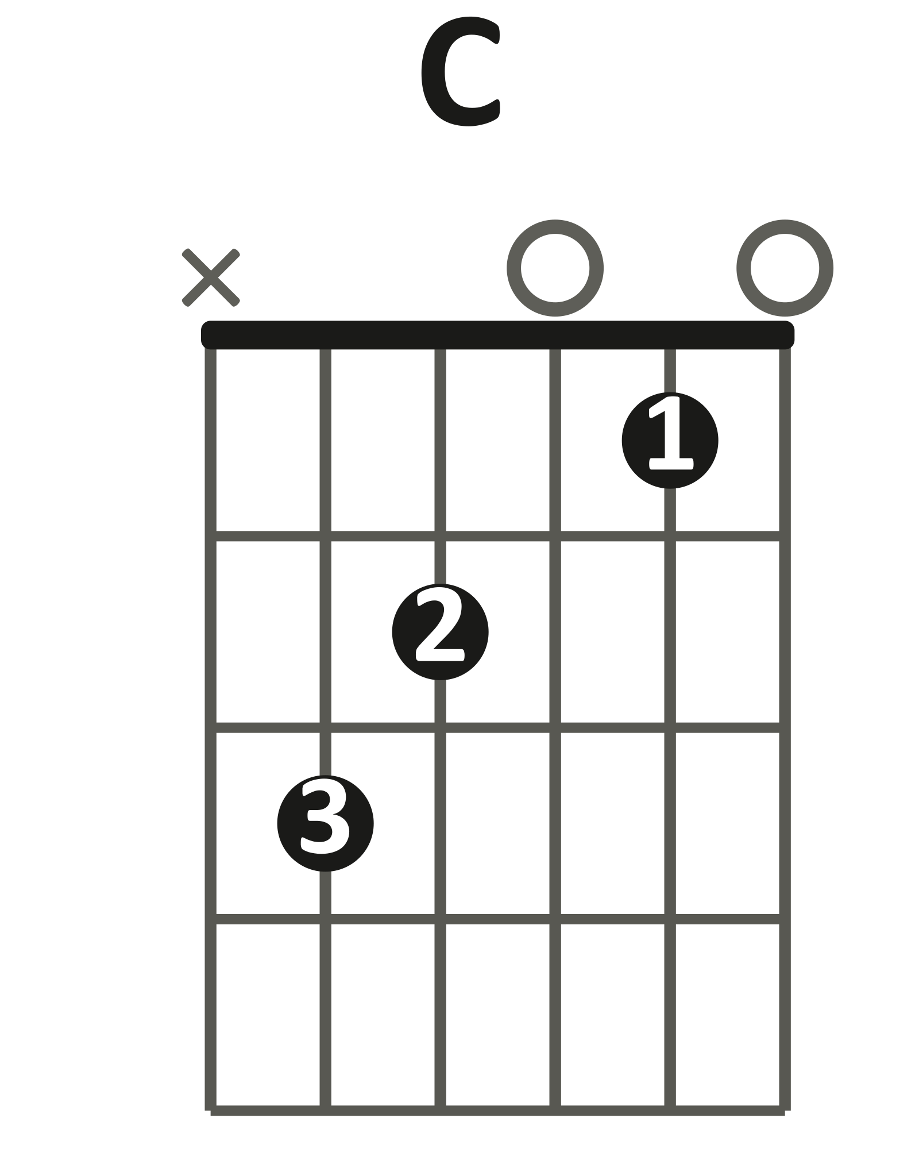 | 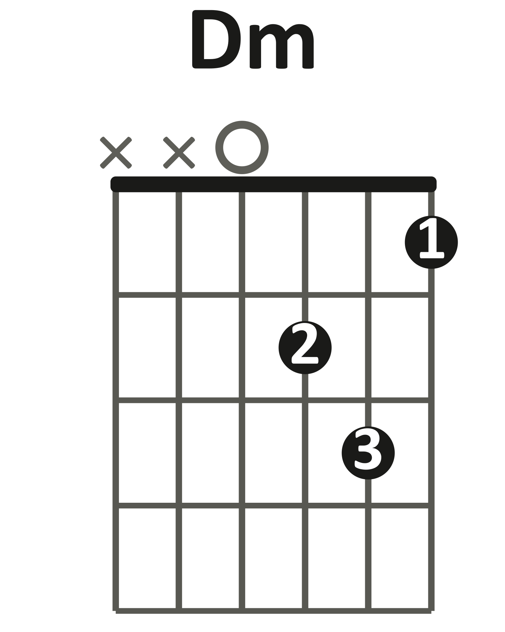 | 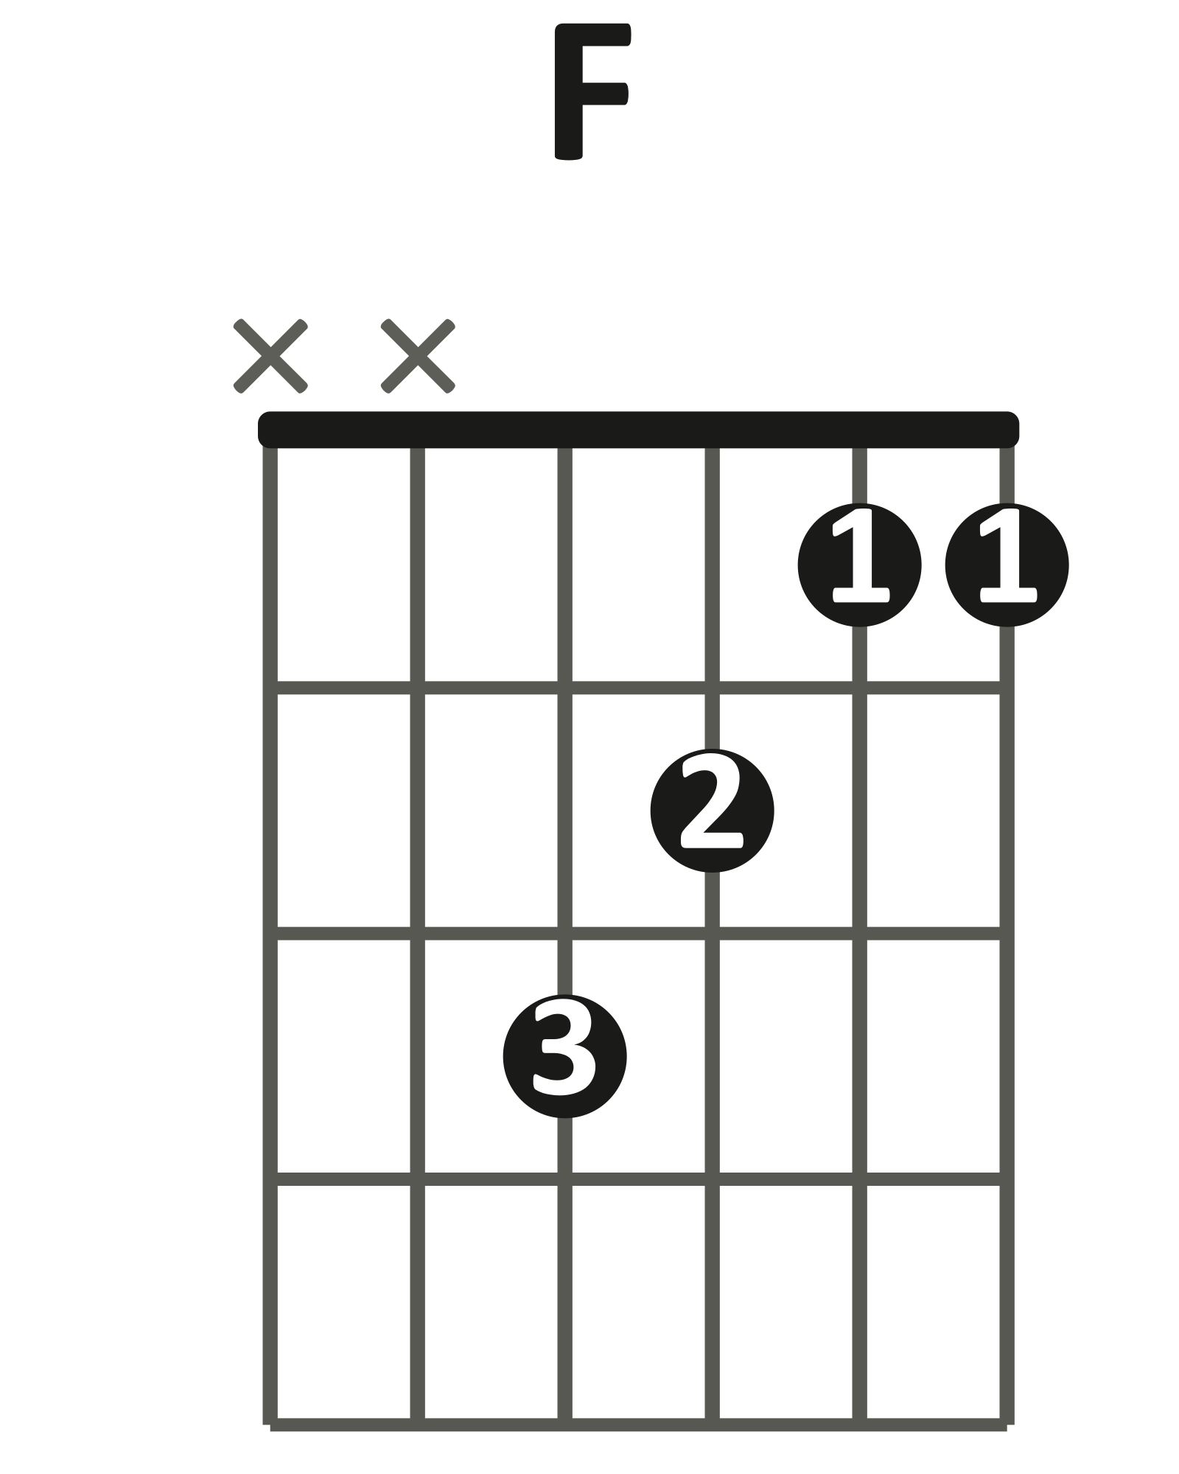  little shape (xx3211) | 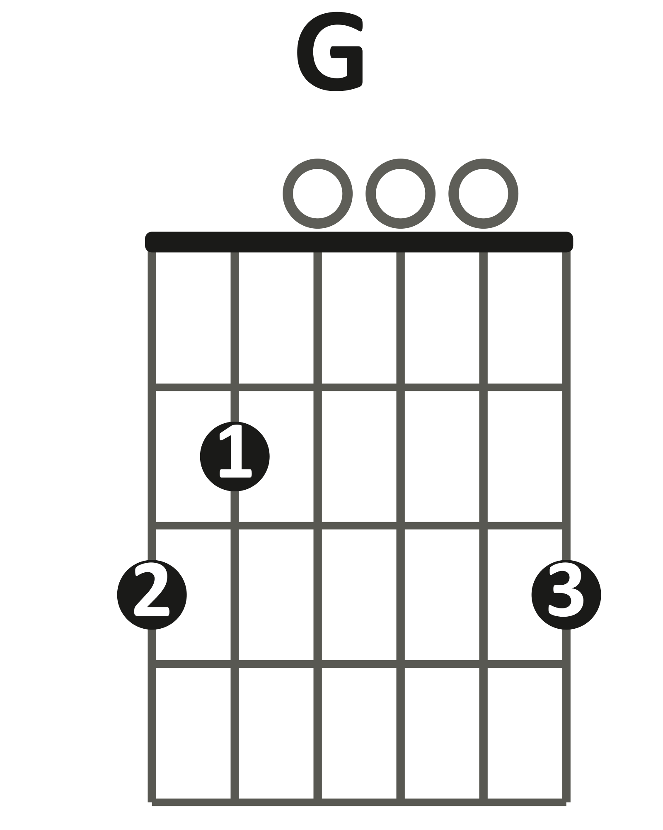  G/B = this G shape, skip the low E string

Open chords · 4 beats per chord · 60 → 65 → 70 BPM
VERSE CHORUS
| Am C | F C | | Dm F | C G/B |
1 2 3 4 1 2 3 4 1 2 3 4 1 2 3 4

Play it: Down-strums, one per beat. Start at 60 BPM. Then 65. Then 70.
G/B = the G shape without the low E string. The B note is now the bass.
You've got it when: 2 clean loops of the verse and 2 of the chorus at 70 BPM. Every change on beat 1.
Level up
Folk strum on every chord: D D U U D U.
Or play with a partner: you strum, your partner solos Layer 4 over you.
Level up · folk strum · one bar per chord
| Am | C |
1 2 & 3 & 4 & 1 2 & 3 & 4 &
D D U U D U D D U U D U

| F | C |
1 2 & 3 & 4 & 1 2 & 3 & 4 &
D D U U D U D D U U D U

LAYER 6 Fingerpicked Verse Bonus
Bonus layer. Optional harder challenge. No score.
No strumming. Pick 8 notes per bar: p i m a m i m i. Two notes per beat.
p = thumb · i = index · m = middle · a = ring. The thumb plays the bass note. The fingers stay on the G, B, and e strings.
thumb: open A | thumb: A string, fret 3 | thumb: D string, fret 3

Am · p i m a m i m i · one bar
e |-----------0--------------|
B |--------1-----1-----1-----|
G |-----2-----------2-----2--|
D |--------------------------|
A |--0-----------------------|
E |--------------------------|

Play it: One bar of Am at 60 BPM. p = open A · i = G string · m = B string · a = high e string.
Then play the whole verse. Only the thumb changes strings.
The verse · one bar per chord · 60 BPM
Am C
e |-----------0--------------|-----------0--------------|
B |--------1-----1-----1-----|--------1-----1-----1-----|
G |-----2-----------2-----2--|-----0-----------0-----0--|
D |--------------------------|--------------------------|
A |--0-----------------------|--3-----------------------|
E |--------------------------|--------------------------|

F C
e |-----------1--------------|-----------0--------------|
B |--------1-----1-----1-----|--------1-----1-----1-----|
G |-----2-----------2-----2--|-----0-----------0-----0--|
D |--3-----------------------|--------------------------|
A |--------------------------|--3-----------------------|
E |--------------------------|--------------------------|

You've got it when: The verse loop Am · C · F · C runs at 60 BPM without stopping.
Level up
Play the chorus the same way: Dm · F · C · G/B.
Thumb: Dm = open D · F = D string, fret 3 · C = A string, fret 3 · G/B = A string, fret 2.
Level up · the chorus · one bar per chord
Dm F
e |-----------1--------------|-----------1--------------|
B |--------3-----3-----3-----|--------1-----1-----1-----|
G |-----2-----------2-----2--|-----2-----------2-----2--|
D |--0-----------------------|--3-----------------------|
A |--------------------------|--------------------------|
E |--------------------------|--------------------------|

C G/B
e |-----------0--------------|-----------3--------------|
B |--------1-----1-----1-----|--------0-----0-----0-----|
G |-----0-----------0-----0--|-----0-----------0-----0--|
D |--------------------------|--------------------------|
A |--3-----------------------|--2-----------------------|
E |--------------------------|--------------------------|

FULL CHORD CHART
"the cure"
Olivia Rodrigo
Key A minor · no capo (capo 1 to match the record)
Tempo Practice at 60 BPM · the record feels like 72 · 4/4
Rhythm One chord per bar · 4 beats each
Form Verse → Chorus → Verse → Chorus → Outro
Shapes you need
Am | C | F | Dm | G

VERSE
| Am | C | F | C |
Soft. Repeat until the chorus.
CHORUS
| Dm | F | C | G/B |
Fuller strumming. G/B = G chord with the B note in the bass.
VERSE
| Am | C | F | C |
Same as the first verse.
CHORUS
| Dm | F | C | G/B |
Same as the first chorus.
OUTRO
The ending. Listen to the record and follow it.
Teaching chart — simplified to match the Journey layers. Chord names are what the class plays in standard tuning.

